Subject: Optical Communication and Networks

Class/Sem: BE EXTC/VIII

Module 5

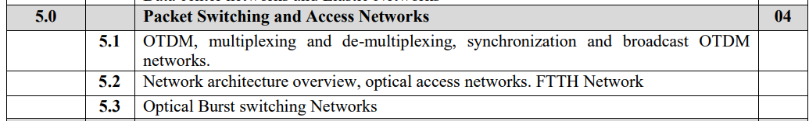

## Optical Time Domain Multiplexing

## A multiplexer is a communication device that can combine several channels into a single channel. Demultiplexing is the process of reconstructing lower data rate signals from a multiplexed signal. There are two types of multiplexing: Electrical Multiplexing and Optical Multiplexing.

## 

## The basic difference between Electrical Multiplexing and Optical Multiplexing is depicted in Figure 1 and Figure 2. Figure 1 represents an electrically multiplexed system. In this figure, thick lines represent the optical path and thin lines represent the electrical path. In Figure 1, multiplexing is done before the Electrical-to-Optical conversion (E/O), and demultiplexing is done after Optical-to-Electrical signal conversion. If a multiplexer carries 'n' number of channels and each has a data rate of 'B', then the multiplexed channel has a data rate of 'nB'. This high data rate information is transmitted onto a single channel. If a full-rate system is used, then bandwidth mismatch occurs at Electrical-to-Optical conversion, Multiplexer, Demultiplexer, and Optical-to-Electrical conversion. This bandwidth mismatch is known as an electronics bottleneck, caused by:

## 

## i) Limited speed of digital circuits.

## ii) Limited speed of high-power amplifiers and modulators used in Electrical-to-Optical converters and in Optical-to-Electrical converters.

## iii) Limited modulation bandwidth of modulators.

## 

## Due to these problems, the maximum bit rate for an electrically multiplexed system is limited to 10 Gbps.

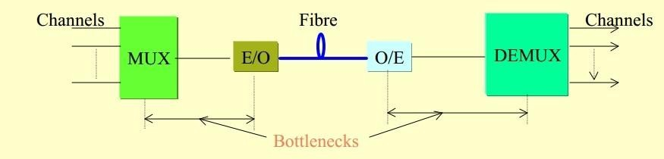

Figure 1 Schematic of Electrical Time Division Multiplexing

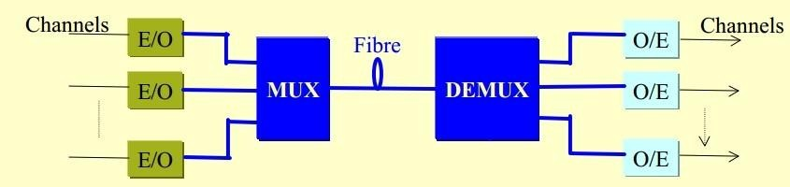

Figure 2 Schematic of Optical Time Division Multiplexing

# In an Optically multiplexed system, these electronics bottlenecks are removed by interchanging the positions of the Electrical-to-Optical (E/O) and Optical-to-Electrical (O/E) converters into the baseband channel. Thus, multiplexing is done after the E/O conversion, and demultiplexing is done before the O/E conversion. It's important to note that a control signal is required to drive the demultiplexer, and this control signal can be either electrical or optical.

# 

# The major difference between electrically multiplexed and optically multiplexed systems is that in an electrical system, the multiplexing and demultiplexing occur at points where the signal has been amplified to large levels in the system. Therefore, the signal-to-noise ratio is determined by the receiver and the noise associated with it. In contrast, in the optical system, the multiplexing and demultiplexing are done on the optical signal. Thus, optical losses are accounted for at the receiver side for the signal-to-noise ratio. Optical losses are small, so the signal-to-noise ratio is larger compared to an electrically multiplexed system.

# Multiplexing Techniques

# Optical fiber provides a large bandwidth. There are three major multiplexing techniques to share this bandwidth:

# 1. Wavelength Division Multiplexing (WDM): In Wavelength Division Multiplexing, two or more optical signals with different wavelengths are combined and simultaneously transmitted in the same direction over an optical fiber.

# 2. Optical Time Division Multiplexing (OTDM): Optical Time Division Multiplexing (OTDM) enables the simultaneous transmission of multiple signals over a single communication line by dividing it into short time segments. Each signal is allocated its own time slot within these segments, allowing for efficient utilization of the channel's bandwidth and enabling high-speed data transmission.

# 3. Hybrid-multiplexing techniques (WDM and OTDM): Hybrid multiplexing techniques combine elements of both WDM and OTDM to further enhance the utilization of the optical fiber bandwidth. This approach may involve utilizing both wavelength and time domains to multiplex signals effectively.

# Wavelength Division Multiplexing

In WDM, two or more optical signals with different wavelengths are combined and simultaneously transmitted in the same direction over an optical fiber. WDM technology is independent of rate and format, and it can support any combination of interface rates. In this context, OC stands for Optical Channel, and 'n' represents how many channels can be multiplexed. For example, OC-n provides n x 51.84 Mbps data rate. Therefore, OC–3 provides 155.52 Mb/s, OC–12 provides 622.08 Mb/s, OC–48 provides 2.488 Gb/s, or OC–192 provides 9.953 Gb/s on the same fiber at the same time. WDM technology is already at an advanced stage of development, and WDM networks can be deployed using commercially available components and systems.

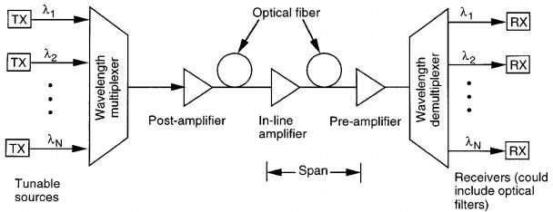

Figure 3 WDM Network

Figure 3 illustrates the implementation of a typical WDM link. At the transmitter side, several independently modulated light sources emit signals at different wavelengths. Here, a multiplexer is needed to combine these optical outputs into a single fiber. At the receiver side, a demultiplexer is required to separate out these optical signals into channels for signal processing. At the transmitter side, the basic design challenge is for the multiplexer to provide a low-loss path from each optical source to the multiplexer output. Since the optical signals that are combined generally do not emit any significant amount of optical power outside of the designated channel spectral width, inter-channel cross-talk factors are relatively unimportant at the transmitting end.

Benefits of WDM System:

* Capacity upgrade: WDM facilitates enhancing the capacity of current point-to-point fiber optic transmission links.
* Transparency: WDM enables the transmission of data in various formats, including asynchronous and synchronous digital data, as well as analog information, along the light path.
* Wavelength Reuse: WDM allows multiple light paths within the network to share the same wavelength, provided they don't overlap on other links, enhancing efficiency.
* Wavelength routing: With WDM, data can be directed along specific paths based on the wavelength of the light signal, optimizing network traffic.
* Wavelength converting: WDM technology allows for the conversion of signals from one wavelength to another, enhancing flexibility and compatibility within the network infrastructure.

## **Type of WDM Network:** There are three Type of WDM:

* Narrowband WDM(NWDM),
* Wideband WDM(WWDM)
* Dense WDM(DWDM).

Generally, NWDM is implemented on two wavelengths: 1533 and 1577 nm. WWDM, is implemented on combining a 1310 nm wavelength with another wavelength into the low loss window of an optical fiber cable between 1528 nm and 1560 nm in wavelength.

DWDM is advanced technology of WDM. Dense wavelength division multiplexing (DWDM) uses 1550 nm wavelength but with denser channel spacing. Channel plans vary, but a typical system would use 40 channels at 100 GHz spacing or 80 channels with 50 GHz spacing.

### Disadvantages of the WDM Technology

* Nonlinearity Effect of the fiber:

There are two ways of the nonlinearity in optical fiber i) Stimulated Raman Scattering and ii) Stimulated Brillouin Scattering.

1. Stimulated Raman Scattering (SRS) is a nonlinear optical process where incident photons interact with material vibrational modes, resulting in the generation of photons with different frequencies, known as Stokes and anti-Stokes scattering.

2. Stimulated Brillouin Scattering (SBS) occurs when incident light interacts with acoustic phonons in a material, leading to the generation of scattered light with a frequency shifted by the frequency of the acoustic wave.

The resultant scattered wave propagates principally in the backward direction in single mode fiber.

* Four wave Mixing (FWM):

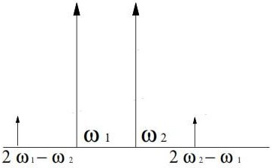

Figure 4. Four-Wave Mixing effect

One of the biggest problems in WDM systems is Four-Wave Mixing (FWM), as shown in Figure 4. FWM occurs when two or more waves propagate in the same direction in the fiber. It is a nonlinear optical process in which multiple input optical waves interact within a nonlinear medium to generate new optical waves at wo different frequencies. It occurs due to the Kerr effect, which causes changes in the refractive index of the medium in response to the intensity of the optical fields.

In FWM, when two or more optical waves with different frequencies propagate through a nonlinear medium, they induce a nonlinear polarization within the medium due to the Kerr effect. This nonlinear polarization generates new optical waves with different frequencies. Specifically, when two input waves with frequencies ω₁ and ω₂ interact, they can produce two new waves: one at the sum frequency (2ω₁ - ω₂) and another at the difference frequency (2ω₂ - ω₁).

These newly generated waves can interfere with the original input waves, leading to phase and amplitude modulation.

**Kerr Effect:** The Kerr effect, named after Scottish physicist John Kerr, is a nonlinear optical phenomenon observed in materials where the refractive index changes in response to an the intensity of incident light. It is a type of optical nonlinearity where the refractive index of a material is directly proportional to the intensity of the electromagnetic field passing through it.

It enables the modulation of light intensity and phase in response to an optical signal, making it essential for manipulating light in optical communication systems, laser systems, and optical signal processing devices.

* self and cross phase modulation

When multiple signals at different wavelengths are present in the same fiber, the Kerr effect caused by one signal can lead to phase modulation of the other signal(s). This phenomenon is known as "Cross-Phase Modulation" (XPM) because it acts between multiple signals rather than within a single signal. Unlike other nonlinear effects, XPM does not involve power transfer between signals. The consequence can be asymmetric spectral broadening and distortion of the pulse shape. It's apparent that XPM cannot occur without also experiencing Self-Phase Modulation (SPM). All these effects contribute to added noise in the system.

* Crosstalk

In WDM technology, crosstalk refers to the interference between different optical channels or wavelengths within the same fiber, degrading signal quality and potentially impacting t ransmission performance.

**Optical Time Division Multiplexing OTDM**

Solution of WDM is OTDM (Optical Time Division Multiplexing) which is introduce in early 1990s

## **Advantage of OTDM:**

* Flexible bandwidth
* Overcomes non-linear effect associated with WDM
* The total capacity of single-channel OTDM network is equal to DWDM
* Less complex end node equipment
* Can operate at both:
  + 1550 nm (like WDM) due to EDFA
  + 1300 nm
* Offers both broadcast and switched based networks

# Basic Principle of OTDM

Indeed, Optical Time Division Multiplexing (OTDM) is a powerful optical multiplexing technique that combines multiple low bit rate channels into a single high bit rate channel based on time division. In OTDM, each channel is multiplexed into the multiplexer for a given period of time, allowing for efficient utilization of the optical fibers bandwidth and enabling high-speed data transmission.

In OTDM, only one wavelength of light is used instead of Different wavelength of light in WDM.

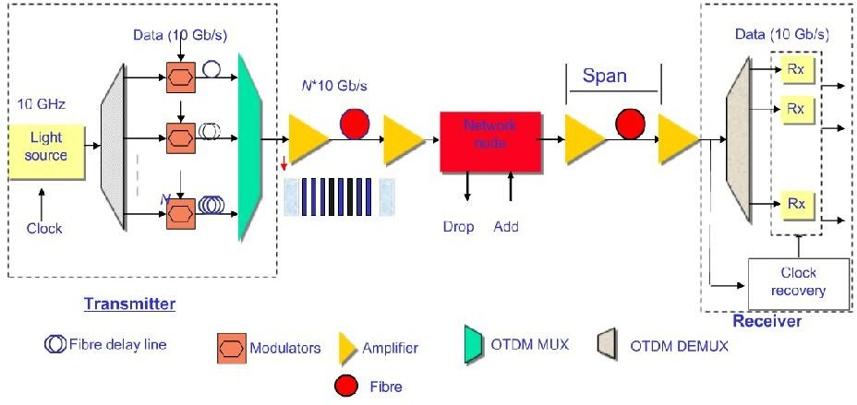

Figure 5.schematic Diagram of Basic principle of OTDM

### General Description

A Simple OTDM system consists of three stages: i) Transmitter, ii) Inline system, and iii) Receiver. The Transmitter comprises an Optical source, Modulator, Channel alignment, and multiplexer. Here, either a Laser or LED can be used as the optical source, and the optical signal can be modulated using Return to Zero (RZ), Non-Return to Zero (NRZ), or Manchester encoding. Various lengths of fiber can be used for channel alignment or to introduce delays in the signal. A multiplexer combines the various optical data streams.

The Inline system includes an optical Amplifier, Add-drop multiplexer, and transmission fiber. Semiconductor Optical Amplifier (SOA) and Erbium-doped fiber Amplifier (EDFA) are used as optical amplifiers to amplify the optical signal within the network.

The Receiver consists of a Demultiplexer and synchronous clock. The synchronous clock is used to extract framing pulses or clock signals. The Demultiplexer comprises two parts: an optical gate and a clock-recovery device. The optical gate is a fast switch with a switching time shorter than the bit period (25 ps for 40 Gb/s, 6.25 ps for 160 Gb/s, 1.56 ps for 640 Gb/s) of the multiplexed data signal. The clock-recovery device provides the timing signal for the optical gate.

# Type of OTDM Multiplexing Techniques

There two ways to multiplexed OTDM signal.

* Bit Interleaving (bit by bit)
* Packet interleaving (Packet by Packet)

If the data stream can be transmitted in form of bit, so it can be done on bit-by-bit basis, as shown in Figure 6.and if the data stream can be transmitted in form of Packet, so it can be done on packet by packet basis Figure 7.

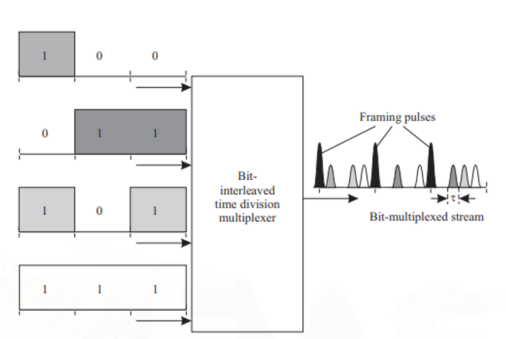

Figure 6 Function of Bit interleaved Optical multiplexer.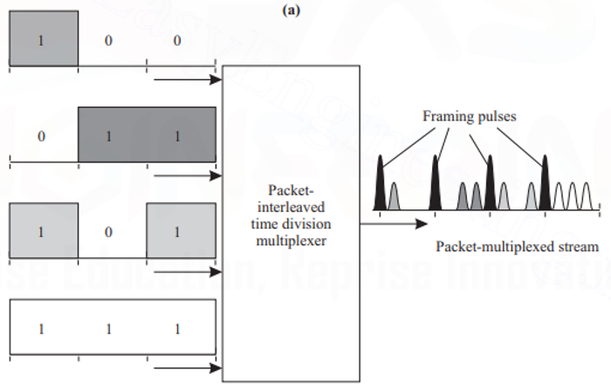

Figure 7 Function of Packet interleaved Optical multiplexer.

In both the bit-interleaved and the packet-interleaved case, framing pulses can be used. In the packet-interleaved case, framing pulses mark the boundary between packets. In the bit-interleaved case, if n input data streams are to be multiplexed, a framing pulse is used every n bits.

If n data streams are to be multiplexed and the bit period of each of these streams is

T. if framing pulses are used, then the inter pulse width is τ = T/(n + 1) because n + 1 pulses (including the framing pulse) must be transmitted in each bit period. Thus the temporal width τ of each pulse must satisfy τp= τ . Note that usually τp≤τ, so that there is some guard time between successive pulses. One purpose of this guard time is to provide for some tolerance in the multiplexing and demultiplexing operations. Another reason is to prevent the undesirable interaction between adjacent pulses that we discussed earlier.

# Bit Interleaving

Multiplexing:-

Bit interleaving operation is illustrated in Figure 8. The periodic pulse train is generated by a mode-locked laser this pulse stream is split by using splitter, and one copy is created for each data stream to be multiplexed. The pulse train for the ith data stream, i = 1, 2,...,n, is delayed by iτ.

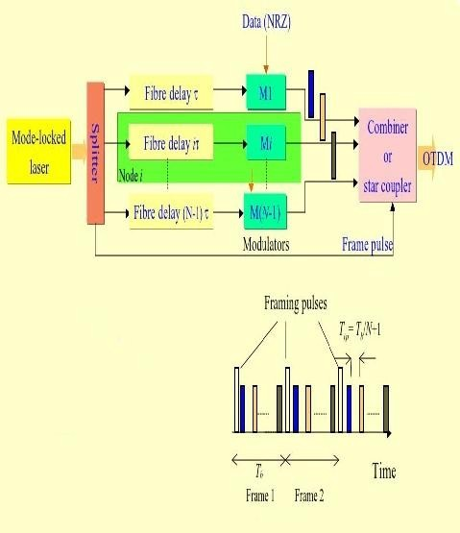

Figure 8 Bit interleaving Operation

This delay can be achieved by passing the pulse train through the different lengths of optical ﬁber. Since the velocity of light in silica ﬁber is about 2 × 108m/s, 1 meter of ﬁber provides a delay of about 5 ns. Thus, the delayed pulse streams are non-overlapping in time. The undelayed pulse stream is used for framing pulses.

Each delayed data stream is modulated by RZ, NRZ techniques, here we using NRZ techniques for modulation. The outputs of the modulator and the framing pulse stream are combined by using combiner and obtain the bit-interleaved optical TDM stream. The power level of the framing pulses is chosen higher than that of the data pulses. This will useful in demultiplexing to spread out the multiplexed OTDM signal.

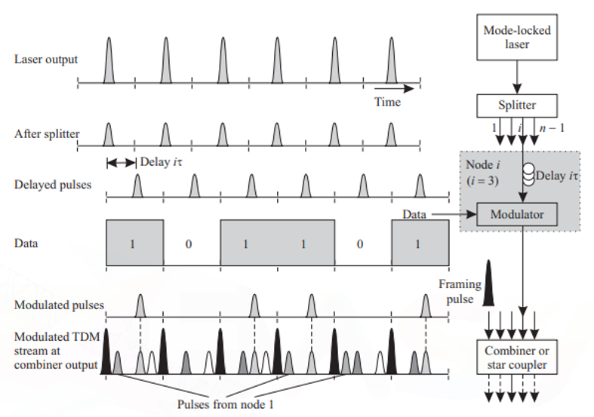

Figure 9 Bit interleaving Operation at single node

### Demultiplexing:-

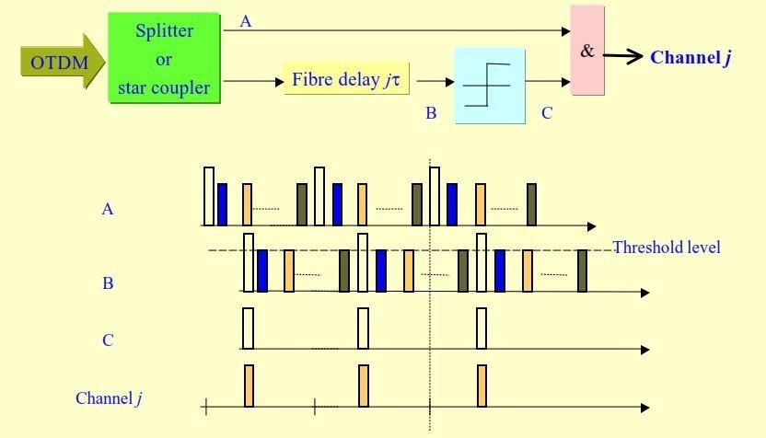

Figure 10 Demultiplexer to extract one of the multiplexed channels from bit interleaving OTDM

The demultiplexing operation is illustrated in Figure 10. The multiplexed input is split into two streams using, a 3 dB coupler. If the jth stream from the multiplexed stream is to be extracted, one of these streams is delayed by jτ. A thresholding operation is performed on the delayed stream to extract the framing pulses. The framing pulses were multiplexed with higher power than the other pulses in order to facilitate this thresholding operation. Note that because of the induced delay, the extracted framing pulses coincide with the pulses in the undelayed stream that correspond to the data stream to be demultiplexed. A logical AND operation between the framing pulse stream and the multiplexed pulse stream is used to extract the jth stream. The output of the logical AND gate is a pulse if, during a pulse interval, both inputs have pulses; the output has no pulse otherwise.

**Packet Interleaving:**

In the case of bit interleaving, modulated data stream has narrow pulses. if the bit interval T, then T separation is required to separate out two successive bit pulse. So, packet interleaving is required. The packet-interleaving operation is illustrated in Figure 11. In packet interleaving, it is required to reduce the interval between successive pulses to τ, corresponding to the higher-rate multiplexed signal. This can be done by passing modulated output from a series of compression stages.

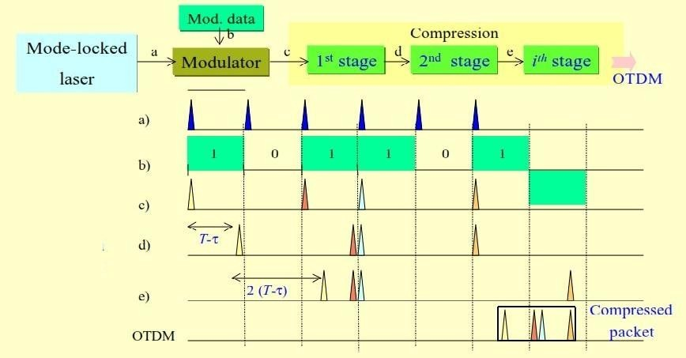

Figure 11. Packet interleaving Operation

If the size of each packet is l bits, then output must goes through k = [log2 l] compression stages. In the ﬁrst compression stage, bits 1, 3, 5, 7,... are delayed by T - τ . In the second compression stage, the pairs of bits (1, 2), (5, 6), (9, 10),... are delayed by 2(T -

τ). In the third compression stage, the bits (1, 2, 3, 4), (9, 10, 11, 12),... are delayed by 4(T -

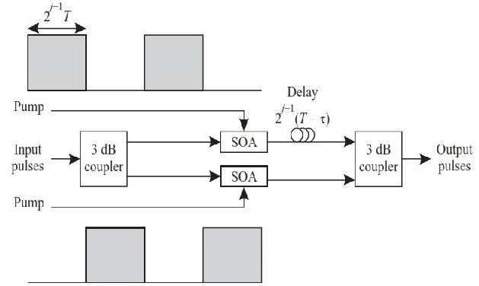τ).

Figure 12. Detailed view of compression stage j

The jth compression stage is shown in Figure 12. Each compression stage consists of a pair of 3 dB couplers, two semiconductor optical ampliﬁers (SOAs) used as on-off switches, and a delayline. The jth compressionstagehasadelaylineofvalue2 j-1(T-τ).

### 

### Demultiplexer

In Demultiplexing, a ﬁve AND gates are used to break up the incoming multiplexed high-speed stream into ﬁve parallel streams each with ﬁve times the pulse spacing of the multiplexed stream.

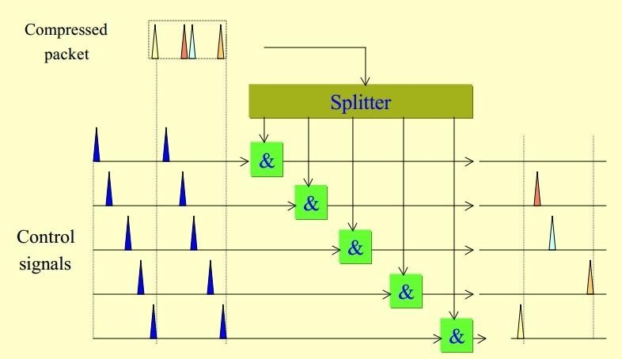

Figure 12. Demultiplexer to extract one of the multiplexed channels from packet interleaving OTDM

This procedure is identical to the one obtaining ﬁve bit-interleaved data streams. One input to each AND gate is the incoming data stream, and the other input is a control pulse stream where the pulses are spaced ﬁve times apart. The control pulse streams to each AND gate are appropriately offset from each other so that they select different pulses. Thus the ﬁrst parallel stream would contain bits 1, 6, 11,... of the packet, the second would contain bits 2, 7, 12,..., and so on. This approach can also be used to demultiplex a portion of the packet, for example, the packet header, in a photonic packet switch.

**Synchronization**

Synchronization is the process of aligning two pulse streams in time. The function of a synchronizer can be understood from Figure 12.13. The two periodic pulse streams, with period ΔT, shown in Figure 12.13(a) are not synchronized because the top stream is ahead in time by ΔT.

In Figure 12.13(b), the two pulse streams are synchronized. Thus, to achieve synchronization, the top stream must be delayed by ΔT with respect to the bottom stream.

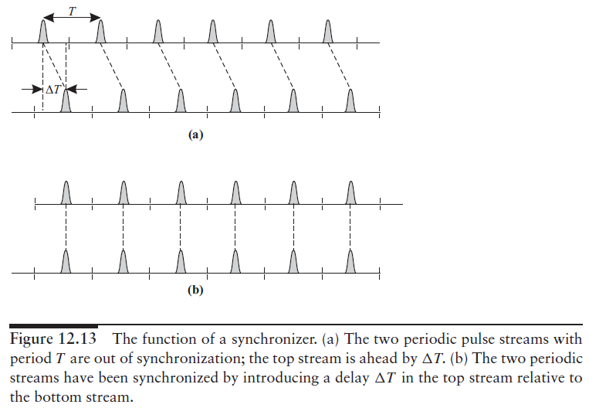

The delays we have considered, for example, while studying optical multiplexers and demultiplexers, have been fixed delays. A fixed delay can be achieved by using a fiber of the appropriate length. However, in the case of a synchronizer, and in some other applications in photonic packet-switching networks, a tunable delay element is required since the amount of delay that has to be introduced is not known a priori. Thus tunable optical delays can be realized.

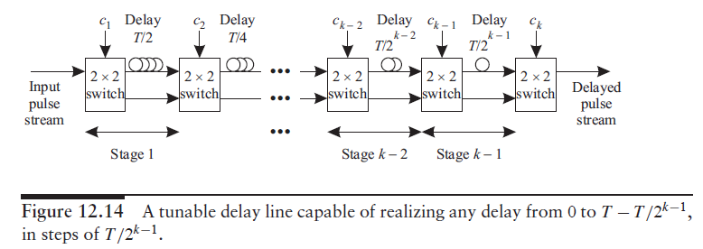

**Access Networks**

The access network is the telecommunications network that runs from the service provider’s facility to the home or business. With fiber now directly available to many office buildings in metropolitan areas, networks based on SONET/SDH or Ethernet-based technologies are being used to provide high-speed access to large business users(consumers of data services).

Telephone and cable companies are also placing a significant emphasis on the development of networks that will allow them to provide a variety of services to individual homes and small to medium businesses.

Homes get essentially two types of services: plain old telephone service (POTS) over the telephone network and broadcast analog video over the cable network. Recently, the data services for Internet access using either digital subscriber line (DSL) technology over the telephone network or cable modem service over the cable network.

Development of high-capacity access networks were devoted networks that would accommodate various forms of video, such as video-on-demand and high-definition television. However, the range of services that users are expected to demand in the future is vast and unpredictable.

Today, end users are interested in both Internet access and other high-speed data access services, for such applications as telecommuting, distance learning, entertainment video, and videoconferencing. Future, unforeseen applications are also sure to arise and make ever-increasing demands on the bandwidth available in the last mile.

At a broad level, these services can be classified based on three major criteria.

* The first is the bandwidth requirement- which can vary from a few kilohertz for telephony to tens of megabits per second per video stream or even tens of gigabits per second for high-speed leased lines.
* The second is whether this requirement is
  + *-symmetric* (two way), for example, videoconferencing, or
  + *-asymmetric* (one way), for example, broadcast video.

Today, while most business services are symmetric, other services tend to be asymmetric, with more bandwidth needed from the service provider to the user (the downstream direction) than from the user to the service provider (the upstream direction).

* The last criterion is whether the service is inherently broadcast, where every user gets the same information, for example, broadcast video, or whether the service is switched, where different users get different information, as is the case with Internet access.

To study different types of existing and emerging access network architectures.

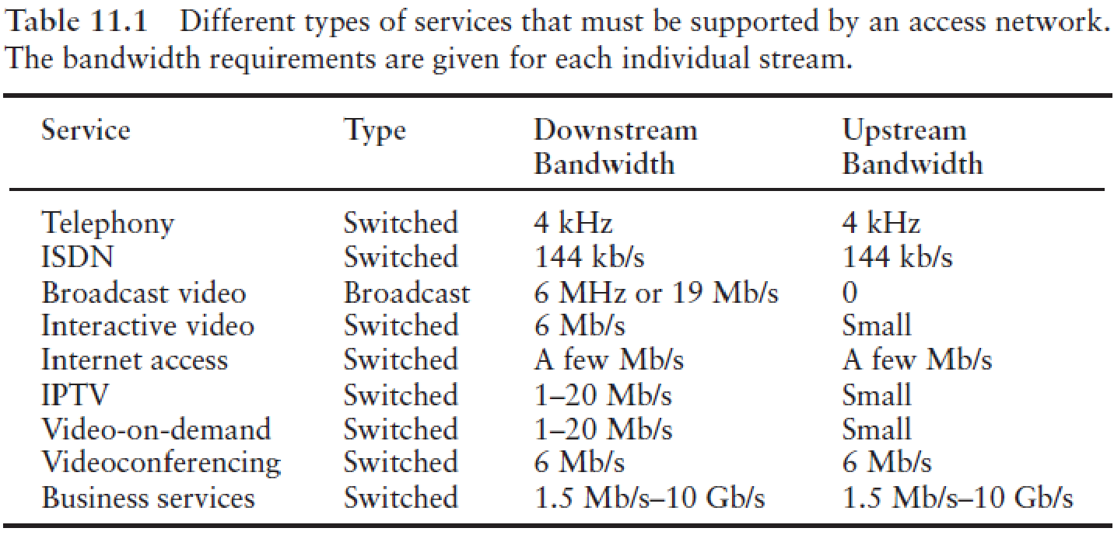

**Network Architecture Overview**

In broad terms, an access network consists of a hub, remote nodes (RNs), and network interface units (NIUs), as shown in Figure 11.1. In the case of a telephone company, the hub is a central office (also called a local exchange in many parts of the world), and In the case of a cable company, it is called a head end.

Each hub serves several homes or businesses via the NIUs. An NIU either may be located in a subscriber location or may itself serve several subscribers.The hub itself may be part of a larger network. Hub acts as the source of data to the NIUs and the sink of data from the NIUs.

In many cases, rather than running cables from the hub to each individual NIU, another hierarchical level is introduced between the hub and the NIUs. Each hub may be connected to several RNs deployed in the field, with each RN in turn serving a separate set of NIUs.

The network between the hub and the RN is called the feeder network, and the network between the RN and the NIUs is called the distribution network.

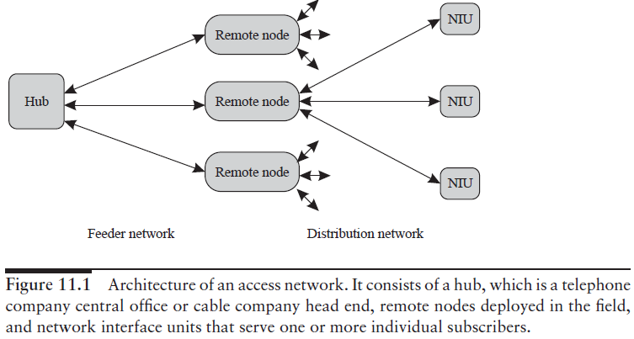

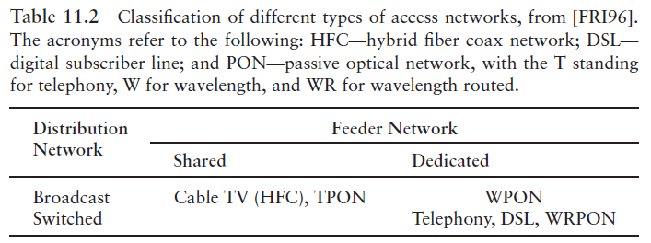

The telephone network is a switched network that provides dedicated bandwidth to each user. The cable network is a broadcast network, with all NIUs sharing the total cable bandwidth. A broadcast WDM passive optical network (WPON), with each NIU assigned a separate wavelength, is an example of a broadcast network but with dedicated bandwidth to each NIU.

Today, two kinds of access networks reach our homes: the telephone network and the cable network. The telephone network runs over twisted-pair copper cable. It consists of point-to-point copper pairs between the telco central office and the individual home.

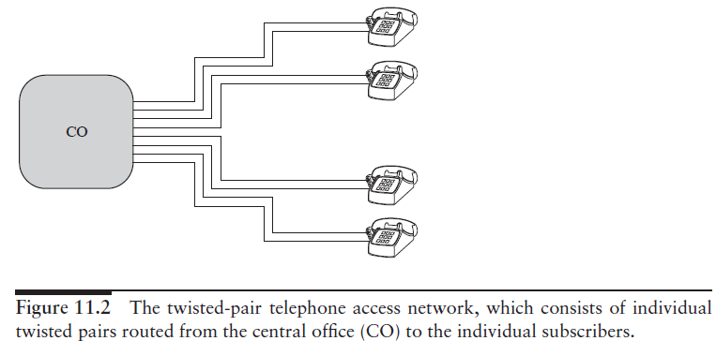

A typical cable network is shown in Figure 11.3. It consists of fibers between the cable company head end (analogous to a telco central office) and remote (fiber)nodes. Usually, the channels from the head end are broadcast to the remote nodes by using subcarrier multiplexing (SCM) on a laser. From the remote node, coaxial cables go to each home. A remote node serves between 500 and 2000 homes. Such a network is called a hybrid fiber coax (HFC) network. The cable bandwidth used is between 50 and 550 MHz.

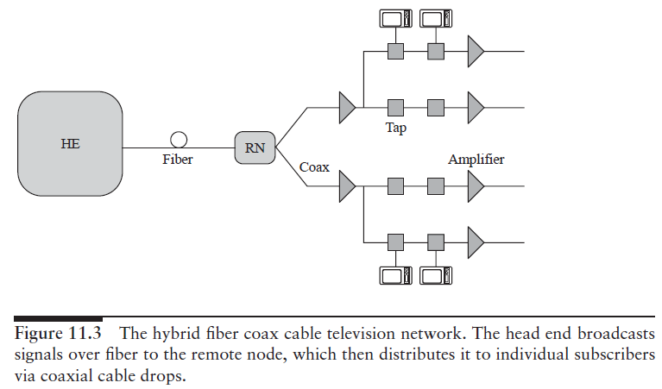

**Future access networks**

Several approaches have been used to upgrade the access network infrastructure. The integrated services digital network (ISDN) provides 144 kb/s of bandwidth over the existing twisted-pair infrastructure.

The digital subscriber line (DSL) is another technique that provides significantly more bandwidth, of few megabits per second, than ISDN, which is sufficient to transmit compressed video. This requires that the central office (CO) and the home each have a DSL modem. ISDN and DSL can be classified as switched networks with dedicated bandwidth per NIU.

**Enhanced HFC**

The upgraded version of HFC architecture, is an enhanced HFC architecture. Since both the fiber and the coax cable carry multiple subcarriers modulated streams, and it is a broadcast network, hence describe as subcarrier modulated fiber coax bus (SMFCB). The network architecture is essentially the same as that shown in previous figure. In order to provide increased bandwidth per user up to 1 GHz from the 500 MHz in conventional HFC systems, the network is being enhanced using a combination of several techniques.

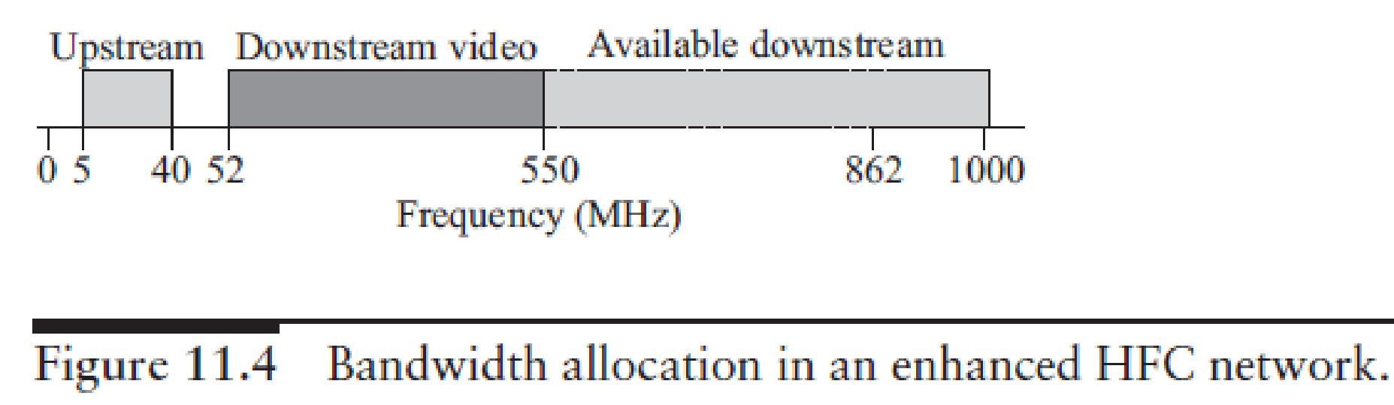

**Fiber to the x**

In fiber to the curb (FTTC), data is transmitted digitally over optical fiber from the hub, or central office, to fiber-terminating nodes called optical network units (ONUs). The expectation is that the fiber would get much closer to the subscriber with this architecture. Depending on how close the fiber gets to an individual subscriber, different terms are employed to describe this architecture (see Figure 11.5).

Fiber to the home (FTTH)- Is the most optimistic scenario, fiber would go to each home. The ONUs would perform the function of the NIUs. FTTC or fiber to the building (FTTB)- For the case where ONUs serve few homes or buildings, say, 8–64.

Typically, in FTTC, the fiber is within about 100 m of the end user. In this case, there is an additional distribution network from the ONUs to the NIUs. Fiber to the cabinet (FTTCab)- The fiber is terminated in a cabinet in the neighborhood and is within about 1 km of the end user.

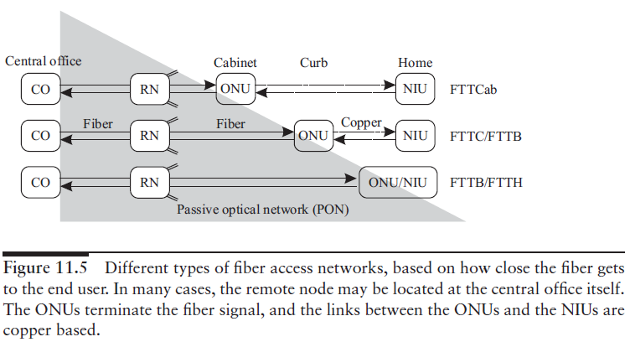

To make the FTTx architecture viable, the network from the CO to the ONU is typically a passive optical network (PON). The International Telecommunications Union (ITU) standardized two generations of TPON. The older ITU-T G.983 standard was based on Asynchronous Transfer Mode (ATM), and has therefore been referred to as APON (ATM PON).

Further improvements to the original APON standard –led to the full, final version of ITU-T G.983 being referred to more often as broadband PON, or BPON. A typical APON/BPON provides 622 megabits per second (Mbit/s) (OC-12) of downstream bandwidth and 155 Mbit/s (OC-3) of upstream traffic, although the standard accommodates higher rates.

The ITU-T G.984 Gigabit-capable Passive Optical Networks (GPON) standard represented an increase, compared to BPON, in both the total bandwidth and bandwidth efficiency through the use of larger, variable-length packets. Again, the standards permit several choices of bit rate, but the industry has converged on 2.488 gigabits per second (Gbit/s) of downstream bandwidth, and 1.244 Gbit/s of upstream bandwidth.

In 2004, the Ethernet PON (EPON or GEPON) standard 802.3ah-2004 was ratified as part of the Ethernet in the first mile project of the IEEE 802.3. EPON is a "short haul" network using ethernet packets, fiber optic cables, and single protocol layer.

EPON also uses standard 802.3 Ethernet frames with symmetric 1 gigabit per second upstream and downstream rates. EPON is applicable for data-centric networks, as well as full-service voice, data and video networks. 10G-EPON supports 10/1 Gbit/s. The downstream wavelength plan support simultaneous operation of 10 Gbit/s on one wavelength and 1 Gbit/s on a separate wavelength for the operation of IEEE802.3 Ethernet.

One way of providing fiber to the home is through a Gigabit Passive Optical Network, or GPON. GPON is a point-to-multipoint access network. Its main characteristic is the use of passive splitters in the fiber distribution network, enabling one single feeding fiber from the provider to serve multiple homes and small businesses. GPON has a downstream capacity of 2.488 Gb/s and an upstream capacity of 1.244 Gbp/s that is shared among users. Encryption is used to keep each user’s data secured and private from other users. Although there are other technologies that could provide fiber to the home, passive optical networks (PONs) like GPON are generally considered the strongest candidate for widespread deployments.

The remote node is a simple passive device such as an optical star coupler, and it may sometimes be colocated in the central office itself rather than in the field. Although many different architectural alternatives can be used for FTTC, the term FTTC is most often used to describe a version where the signals are broadcast from the central office to the ONUs, and The ONUs share a common total bandwidth in time division multiplexed fashion.

The optical networks proposed for this application are commonly called PONs (passive optical networks)—all of them use passive architectures. They use some form of passive component, such as an optical star coupler or a static wavelength router, as the remote node. The main advantages of using passive architectures in this case come from their reliability, ease of maintenance, and the fact that the field-deployed network does not need to be powered. Moreover, the fiber infrastructure itself is transparent to bit rates and modulation formats, and the overall network can be upgraded in the future without changing the infrastructure itself.

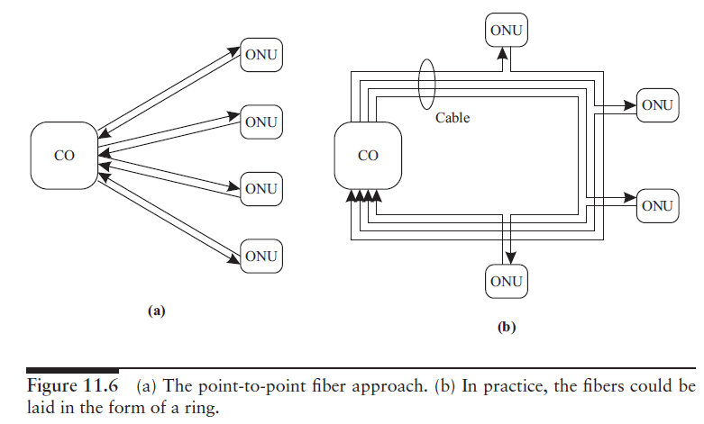

Instead of providing a fiber pair to each ONU, a single fiber can be used with bidirectional transmission. However, the same wavelength cannot be used to transmit data simultaneously in both directions because of uncontrolled reflections in the fiber. One way is to use time division multiplexing so that both ends do not transmit simultaneously. Another is to use different wavelengths (1.3 and 1.55 μm, for example) for the different directions.

More commonly, rather than dedicating a fiber pair per user, the fiber pair is shared by many users. The most common example of such networks are the SONET/SDH rings, which are now widely deployed to provide high-speed services to large business customers. These rings operate at speeds ranging from 155 Mb/s to 10 Gb/s. In this case, an ONU is a SONET add/drop multiplexer (ADM), and multiple ONUs can be present on the same ring.

PON architectures provide a more cost-effective solution for addressing the needs of small- and medium-sized businesses and homes, which require a few DS1 (1.5 Mb/s) lines, DSL lines, or 10 Mb/s Ethernet connections.

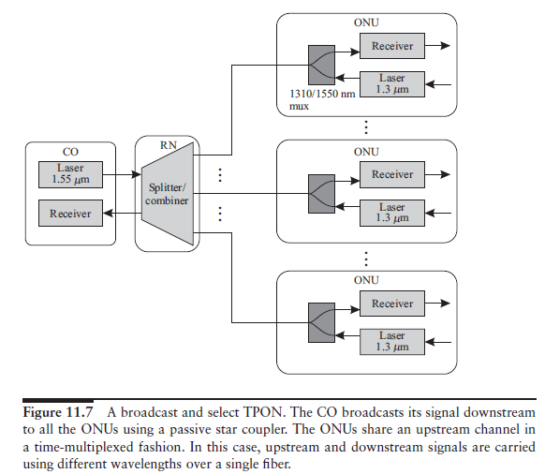

Common PON architecture is the TPON (originally called PON for telephony) architecture, shown in Figure 11.7. The downstream traffic is broadcast by a transmitter at the CO to all the ONUs by a passive star coupler.Although the architecture is a broadcast architecture, switched services can be supported by assigning specific time slots to individual ONUs based on their bandwidth demands. For the upstream channel, the ONUs share a channel that is combined using a coupler, again via fixed time division multiplexing (TDM) some other multiaccess protocol. In the TDM approach, the ONUs need to be synchronized to a common clock.

This is done by a process called ranging, where each ONU measures its delay from the CO and adjusts its clock such that all the ONUs are synchronized relative to the CO. The CO then assigns time slots to each ONU as needed.

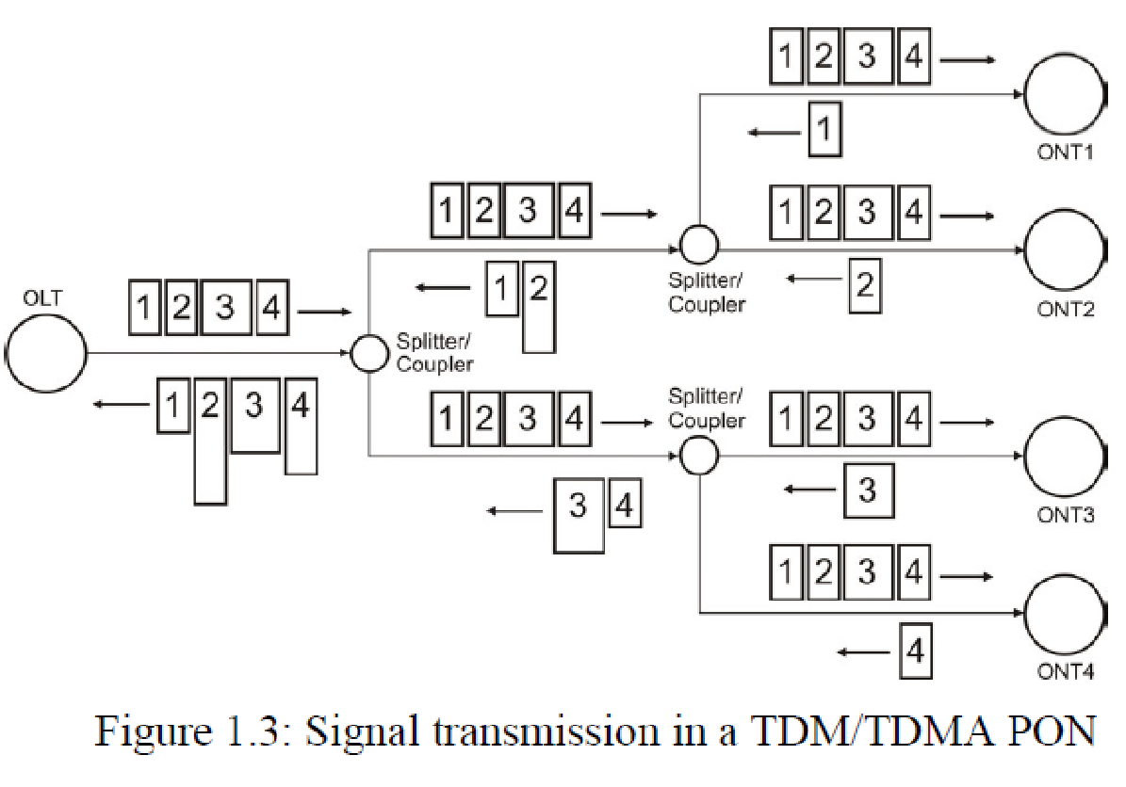

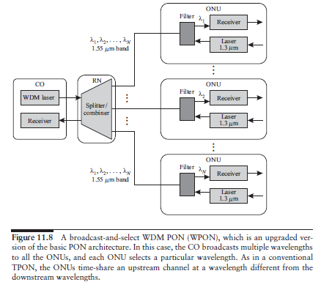

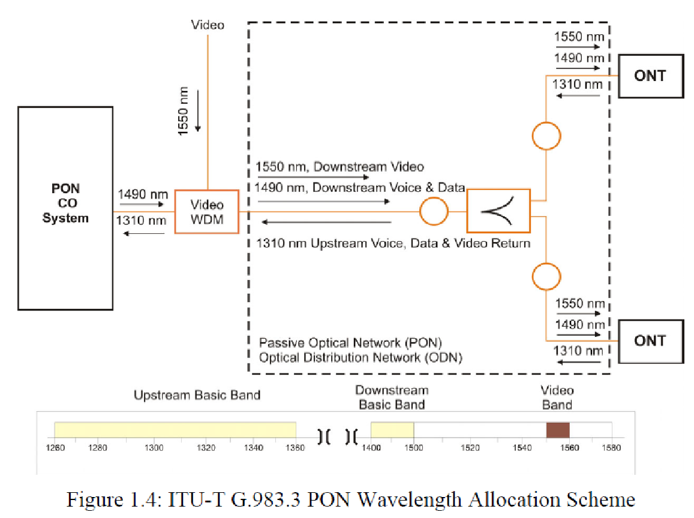

WDM technology can be applied to TPONs. WDM can increase the capacity and flexibility of TPONs. An architecture to implement WDM into a TPON is shown in Figure 11.8. Single transceiver at the CO is replaced with a WDM array of transmitters or a single tunable transmitter to yield a WDM PON (WPON). Each ONU is equipped with electronics, running only at the rate it receives data.

However, it is still limited by the power splitting at the star coupler.

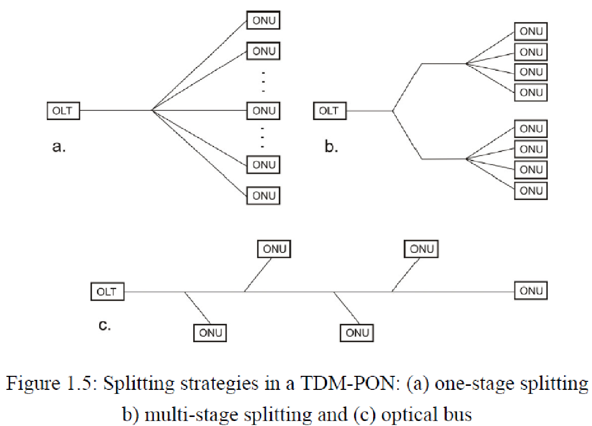

Most of the commercial PON systems have a splitting ratio of 1:16 or 1:32. A higher splitting ratio means that the cost of the PON OLT is better shared among ONUs. However, the splitting ratio directly affects the system power budget and transmission loss. The ideal splitting loss for a 1:N splitter is 10*log(N) dB. To support large splitting ratio, high power transmitters, high sensitivity receivers, and low-loss optical components are required. Higher splitting ratio also means less power left for transmission fiber loss and smaller margin reserved for other system degradations and variations. Therefore, up to a certain point, higher splitting ratio will create diminishing returns.

A high splitting ratio also means the OLT bandwidth is shared among more ONUs and will lead to less bandwidth per user. To achieve a certain bit error rate (BER) performance, a minimum energy per bit is required to overcome the system noise. Therefore, increasing the bit rate at the OLT will also increase the power (which is the product of bit rate and bit energy) required for transmission. The transmission power is constrained by available laser technology (communication lasers normally have about 0–10 dBm output power) and safety requirements issued by regulatory authorities.